Water Monitoring & Purification Device sensors and their actuation and control method.
4-channel 5V Relay module:
No, a standard 4-channel 5V relay module cannot detect heavy metals like lead, mercury, manganese, or magnesium; this module is designed to act as a high-power switch, not a sensor. To detect these metals, you would need a separate sensor designed for that specific purpose, which would then send a signal to the microcontroller to control the relay.
Function of a 4-channel 5V relay module:
- Switching:
A relay module's primary function is to use a low-voltage signal from a microcontroller (like an ESP32-S3) to switch a high-voltage or high-current circuit on or off.
- Controlling devices:
It's used to control appliances, motors, lights, or other devices that require more power than a microcontroller's digital pins can handle directly.
- High-current capacity:
Each relay on the module can typically handle loads of up to 250VAC or 30VDC at 10A
What we need for water purification device:
- Sensor:
A separate sensor that can chemically or electronically detect the specific heavy metals (lead, mercury, etc.) in the water.
- Microcontroller:
A device like an ESP32-S3 to read and write the signal from the sensor and process the data.
- Relay module:
The 4-channel 5V relay module would be used by the microcontroller to control the purification device, such as turning a pump on or off or activating a purification element, after the sensor has detected a problem.
Specifications:
- Output controllable: Digital
- Compatible: With any 5V microcontroller such as ESP32-S3.
- Rated through-current: 10A (NO) 5A (NC)
- Control signal: TTL level
- Max. switching voltage: 250VAC/30VDC
- Max. switching current: 10A
- Size: 76mm x 56mm x 17mm
Applications:
- Home automation
- Industrial automation
- Robotics
- Smart garden Systems
- Security system
- DIY and Hobbyist projects
- Automobile Applications
- Water purification devices.
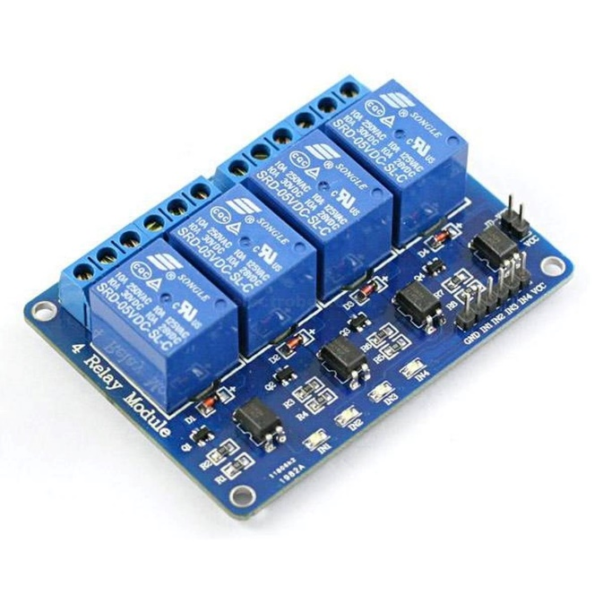
Figure 1:4-channel 5V relay module
12V DC Solenoid Valves (Normally Closed):
A 12V DC solenoid valve does not detect lead, mercury, manganese, or magnesium; rather, it is a component that controls water flow in a purification device. These valves simply act as an automatic shut-off, opening to allow water into the system and closing to stop the flow when the purification process is complete or a water sensor determines purity is reached. The detection of contaminants is performed by separate sensor modules within the purification system.
Solenoid valve function:
- Control not detection:
The valve's primary function is to regulate water flow, not to test water quality.
- How it works:
It uses an electromagnetic coil to open or close the flow path.
- When energized (12V DC power is supplied), it opens, allowing water to enter the purification device.
- When de-energized, it closes, stopping the water flow.
- Role in purification:
It is an essential component that automates the on/off function of the water purifier, but it relies on other components, such as sensors, to determine when to open and close.
- Example use case:
- In a water purifier, the solenoid valve opens when the system is ready to purify water and closes when the water is pure, which is determined by a sensor that detects the absence of contaminants.
Features:
- The valve body is made of all-plastic material, with 4 points of external thread on both ends of the valve body. The valve body is simple, the power terminal is insert type, and the 6.3 spring is used.
- The coil is packaged by the international top-grade coil packaging material, and has the advantages of waterproof, moisture-proof, wear-resistant, corrosion-resistant, high-low temperature resistance.
- The insulation grade is high, and the heat dissipation effect is good. Under normal conditions, the product can be used for a long time.
- This valve is a normally closed solenoid valve, that is, it is energized to turn on (water), and the power is off (water cut).
- This is a micro pressure valve (pressure), suitable for 0.02-0.8MPA water pressure, please choose according to our actual needs.
Specifications:
- Voltage: DC 12V
- Operation mode: N/C, normal close
- Inlet/Outlet Ports: 1/2″ to 1/2″, GB screw thread
- Response Time: ON≤0.15s, OFF≤0.3s
- Rectification: synchronous rectification
- Filter Screen: Stainless Steel Inlet Filter
- Pressure: 0.02-0.8Mpa
- Temperature: 0-100°C
- Flow characteristic: 0.02Mpa≥3 L/min; 0.1Mpa≥12 L/min; 0.8Mpa≥35 L/min
- Usage: water and low viscosity fluids
Applications:
- Water control: Irrigation systems, Ornamental water features and Water treatment plants.
- Industrial and DIY: Fluid control, Air compressors and Pneumatic and fuel systems.
- Automotive and HVAC: HVAC systems and Automotive.
- Medical and Analytical Instruments: Medical devices and Pinch valves.
- Water purification devices
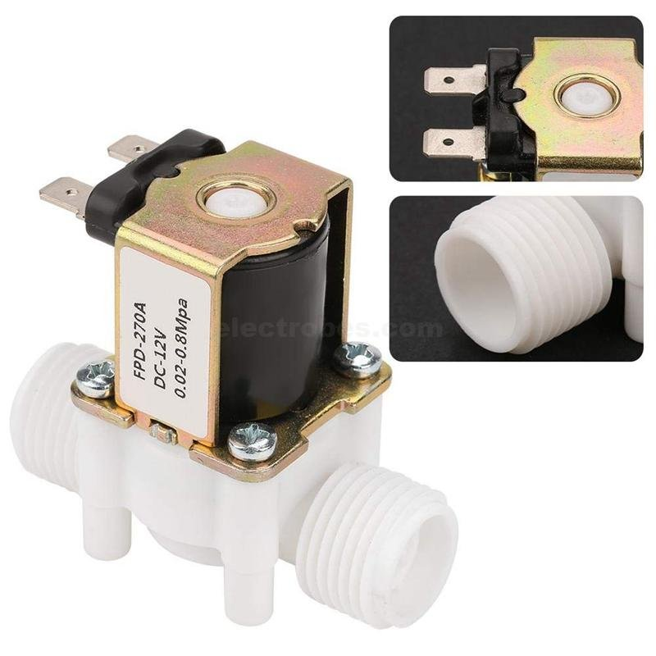
Figure 2: 12V DC Solenoid Valves (Normally Closed)
5V Peristaltic Dosing Pump:
A 5V peristaltic pump cannot detect lead, mercury, manganese, or magnesium; it is a liquid-handling device that doses and transports fluids. Detection requires separate sensors, such as electrochemical or spectroscopic sensors, which can be integrated with a purification system to work alongside a dosing pump that adds reagents or chemicals to process the water.
What a peristaltic pump does:
- Moves liquid:
A peristaltic pump uses rollers to squeeze a flexible tube, creating a vacuum to move liquid through it.
- Transports, not detects:
Its function is solely to move fluids precisely, not to analyze their chemical composition.
- Doses chemicals:
In a purification device, it could be used to inject chemicals needed for the purification process, such as disinfectants or flocculants, according to user or sensor-driven commands.
How a purification system detects contaminants:
- Uses sensors:
A water purification system that detects lead, mercury, manganese, or magnesium would use dedicated sensors (like electrochemical sensors) to identify and quantify these elements.
- Dosing pump’s role:
Once the sensors detect contaminants, they would send a signal to the control system. The control system would then instruct the peristaltic pump to dose a specific amount of a chemical or reagent to neutralize or remove the contaminants.
Specifications:
- Working Temperature: 0℃ - 40℃
- Motor voltage: 5 to 6 VDC
- Motor current: 500mA
- Flow rate: up to 100 mL/min
- Weight: 104 grams
- Dimensions: 27.8mm diameter motor, 66.8mm total length
- Mounting holes: 3.7mm diameter, 50mm center-to-center distance
- Tube length: approx. 530mm / 20.8"
- Tube diameters: inner diameter 3.5mm, outer diameter 5mm
Features:
- Low voltage and power:
Operates on 5V DC, allowing for use with USB power banks or batteries and consuming low energy.
- Low voltage and power:
Operates on 5V DC, allowing for use with USB power banks or batteries and consuming low energy.
- Direction control:
Flow direction can be reversed by simply switching the positive and negative connections to the motor.
- Precise control:
Can be controlled with PWM (Pulse Width Modulation) signals for fine-tuning the flow rate. Some models offer higher precision with encoder feedback.
- Direction control:
Flow direction can be reversed by simply switching the positive and negative connections to the motor.
- Precise control:
Can be controlled with PWM (Pulse Width Modulation) signals for fine-tuning the flow rate. Some models offer higher precision with encoder feedback.
Applications:
- Water purification
- Automated Dispensers
- Aquariums and Hydroponics
- Smart Home Devices
- Medical and Laboratory
- DIY and Educational Projects
- Analytical Instruments
- Cleaning and Maintenance
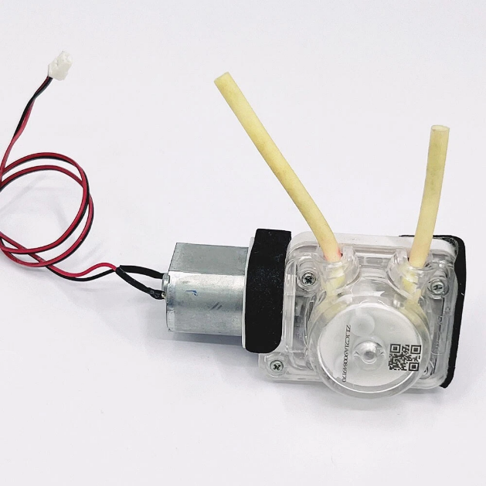
Figure 3: 5V Peristaltic Dosing Pump

12V DC Diaphragm Water Pump
No, a standard 12V DC diaphragm water pump does not detect or filter out specific contaminants like lead, mercury, manganese, or magnesium. Its function is to move water, not to purify it by removing heavy metals. For water purification, a separate filter system or reverse osmosis unit is necessary to remove these contaminants after the pump has supplied water to it.
Function of a 12V DC diaphragm pump:
- Pumps water:
It is designed to move water from one point to another, often used for tasks like garden watering, car washing, or supplying water to showers in an RV.
- Pressure and flow:
These pumps can operate at high pressure and deliver a smooth, consistent flow.
- Self-priming:
Many models can self-prime, meaning they can start pumping after the pump is mounted above the water source.
- Automatic shut-off:
Many have a built-in pressure switch that turns the pump on and off automatically when a faucet is opened or closed.
How to remove metals:
- Separate purification system:
To remove contaminants like lead, mercury, manganese, and magnesium, we need a separate water purification device.
- Examples of purification systems:
Common methods include multi-stage filters (like those found in pitcher filters) or more advanced systems like reverse osmosis (RO) systems, which are specifically designed to remove these types of heavy metals.
- Role of the pump:
The 12V pump can supply the water pressure needed for these purification systems to work effectively.
Features:
- Durable and practical.
- Made of high quality plastic and metal, long life.
- It is very convenient to use, open or close when power on or off.
Specifications:
- Body Material: Brass
- Working fluid : air, water, oil
- Type : normally closed
- Take over pore diameter : 1/2
- Operating Viscosity: Under 20CST
- Seal Material : NBR
- Voltage : 12V AC/DC
- Pressure range : 0kg/cm² – 10kg/cm²
- Fluid temperature : -5 – 100 ℃

